IT24100343

Kavindya M.H.H

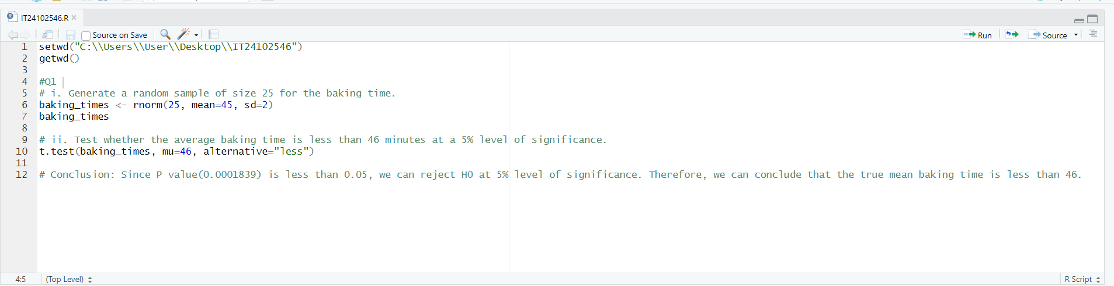PS Lab sheet 9

